**SENTIMENT ANALYSIS FOR EVALUATING ISP SERVICES IN NIGERIA**

**BY**

**AKINLOLU MARTHA TOSIN 1**

**&**

**DR. O.O. AJAYI 2**

**1Computer Science, Adekunle Ajasin University, Akungba, Ondo State, Nigeria.** [**marthaakinlolu@gmail.com**](mailto:marthaakinlolu@gmail.com)

**2Computer Science, Adekunle Ajasin University, Akungba, Ondo State, Nigeria.** [**olusola.ajayi@aaua.edu.ng**](mailto:olusola.ajayi@aaua.edu.ng)

**APRIL, 2019**

**ABSTRACT**

*There are issues about internet access in Nigeria, people find it hard to go online and some find it difficult to connect. Users experience some variable factors which made them unease to having access to a working internet service with the use of ISP networks. Some of these experiences include: network congestion, slow control mechanisms, high data rates, malwares, bad network connection etc. In some cases, the amount of bandwidth available may fall below the threshold to support a particular service such as video conferencing or streaming live video effectively, making the service unavailable. People’s opinions about a product have always been important most especially in the market world. It helps the manufacturers to know consumers’/customers’ views about their products whether positive, negative or neutral. Due to these challenges, there is a need for a platform whereby the user or client will be able to give a feedback about the service rendered by the ISPs.*

*This study shall therefore be capturing and analyzing the opinions/views/attitudes of people about the services provided by some common and selected ISPs in Nigeria. Google form was designed and used to capture users’ complaints/comments about the services received from the selected ISPs. The results of their responses were stored into database in form of .csv, while python was used as the programming language for the processing and analysis of the users’ responses.*

**Keywords**: Internet; ISPs; Sentiments; Sentiment analyses; Sentiment Classification; Opinion mining; Evaluation; Attitudes; Emotions; Thought; Natural Language Processing (NLP); Social Media; Social Platform; Structured System Analysis and Design Methodology (SSADM)

1. **INTRODUCTION**

The world wide web (WWW) became available in Nigeria in 1996, while full internet services became available in 1998 and number NCC (Nigerian Communications Communication) licensed internet services provider rose over 150 in 2001 [1] (Adomi, 2005).

The internet has made it possible for scholars at different locations on the globe to exchange ideas on various fields of study and allow students and lecturers to communicate within and across international borders (Luambano and Nawe, 2004). Due to the global use of social media, whereby people can connect together within the globe. The internet helps provide access for them to be able to reach out to friends all over the World. Also, in school, internet helps students to get information for their assignment, research work, class topics, etc.

Furthermore, in banking, internet has helped with easy mobile banking whereby cashless policy is fast developing. Also, for marketing, goods can be purchased online and be delivered at one’s door step. There is a synergy between broadcasting and the internet, which is a critical success factor for future growth, as information is gotten at a point but viewed in various places in seconds or lesser minutes.

An internet service provider (ISP) is an organization that provides services accessing and using the internet. Internet services typically provided by ISPs include internet access, internet transit, domain name registration, web hosting, Usenet service and collocation. ISPs provide internet access, employing a range of technologies to connect users to their network.

ISPs are company that provides users and companies, corporation and government accesses to internet creation of website and virtual hosting. ISPs use devices in the communication technology to install access links in an area. Some of the larger ISPs operate a high-speed broadband. [25] (Mu’azu *et al*, 2015).

In Nigeria, Internet Service is a fast-growing business that helps people connects globally for information and knowledge acquiring. So, with the aid of Internet Service Provider (ISP), they help provide access to internet. They sell in Bytes (i.e. MB, GB, etc.) which are in variable units.

So far, there has been an issue about internet access in Nigeria, people find it hard to go online and some find it easy to connect. Users experience some variable factors which makes them unease to having access to a working internet service with the use of ISP networks. Some of these experiences include: network congestion, slow control mechanisms, high data rates, malwares, and bad network connection i.e. connection receiving less bandwidth. In some cases, the amount of bandwidth available may fall below the threshold to support a service such as video conferencing or streaming live video – effectively making the service unavailable. When traffic is particularly heavy, an ISP can deliberately throttle back the bandwidth available to classes of users or for services. This known as traffic shaping and careful use can ensure a better quality of service for time critical services, even on extremely busy network. However, overuse can lead to concerns about fairness and network neutrality or even charges of censorship, when some types of traffic are severely or completely blocked.

Therefore, this study shall be analyzing the opinions/views/attitudes of people about the services provided by some ISPs.

Sentiment Analysis (SA) refers to the application of Natural Language Processing (NLP), computational linguistics, and text analytics to identify and extract subjective information in source materials such as those discussions about certain products and services [30] (Roebuck, 2012). Sentiment analysis is the computational study of people’s opinions, attitudes, and emotions toward an entity. The input can represent individuals, events or topics which most likely are coming from reviews, tweets, and comments [2] (Ahmadi, 2017).

Sentiment analysis (also sentiment mining, sentiment classification, opinion mining, subjectivity analysis, review mining or appraisal extraction, and in some cases polarity classification) deals with the computational treatment of opinion, sentiment, and subjectivity in text (Pang & Lee 2008). It intends to ascertain the attitude or opinion of a speaker or writer with respect to a certain topic or target. The attitude could reflect his/her judgment, opinion or evaluation, his/her affective state (how the writer feels at the time of writing) or the intended emotional communication (how the writer wants to affect the reader) (Mejova, 2009).

According to Blessy and Abiram [9] (2013), the explosion of social media has created unprecedented opportunities for citizens to publicly voice their opinions, but when it comes to making sense of these opinions then it is a serious problem. Opinion mining is a type of natural language processing for tracking the mood of the public about a product. Opinion mining involves building a system to collect and examine opinions about the product made in blog posts, comments, reviews or tweets. Opinion mining can be useful in several ways in marketing, it helps to judge the success of a determine which versions of a product or service are popular and even identify which launch of new product, demographics like or dislike particular features. After the process of opinion extraction, the Sentiment analysis determines the subjectivity, polarity and polarity strength of a piece of text. The sentiment-oriented words are used for providing a good recommendation to the users to make accurate decision.

People’s opinion and thinking about a product or political concept has always been important most especially in the market world. It helps the manufacturer to know consumers/customers view about their product whether positive, negative or neutral.

The applications for sentimental analysis are endless. It’s being used in social media for monitoring customer’s reviews, survey responses, competitors, etc. Sentiment analysis is in demand because of its efficiency. Thousands of text documents can be processed for sentiment (and other features including named entitles, topics, themes, etc.) in seconds compared to the hours it would take a team of people to manually complete. Because it is so efficient, and accurate many businesses are adopting the text and sentiment analysis and incorporating it into their processes.

In this work, sentiment analysis shall be used to collect data (opinion) through google form, twitter, Facebook, WhatsApp etc. These social platforms are the fast-developing networks that are visited daily, also been used on mobile phones which can be of aid to providing fast responses from the customers. The use of sentiment analysis in getting people’s opinion on ISP is very essential. It will help us identify the attitude or reactions of people concerning some ISPs and it will allow the ISPs to work better on their internet to avoid them losing lots of customers.

1. **Related Work**

Due to the fast growth of the Social Network, many researchers have used the social platform to carryout works relating to opinion mining or sentiment analysis. So, in this chapter, related works is reviewed.

Asur and Huberman [5] (2010) worked on predicting the future with social media. In this paper author predict the real-world outcomes like tweets and movie revenues from Box-Office. In social media movies name is one of the most interesting thing and when movie trailer is out user can predict the future of movie and movie producers and co-sponsor tries to promote the movie that creates a buzz in box-office. The main goal of this paper is to demonstrate how social media content can be used to predict real-world outcomes. In particular, the chatter from Twitter.com was used to forecast box-office revenues for movies. It furtherly shows how sentiments extracted from Twitter can be further utilized to improve the forecasting power of social media. Dynamic LMC classifier is use by author to predict the future of movies. DLMC is a language classifier that helps in sentiment analysis and that is based on trained data set rules or dictionary.

In Anu and Savleen [4] (2016), the focus was the techniques for sentiment analysis and text summarization survey. In this paper, author deploys that sentiment analysis can be done on approaches like machine learning that use trained set of data or can also be called a supervised approach. And also gave another alternative approach which is Lexicon based approach in which this now trained data set is been used but it has pre-define dictionary related to words that are mostly used and the third one is hybrid that is combination of both machine learning as well as lexicon based approach.

Ahmadi Mojtaba [2] (2017) carried out A Sentiment Analysis Application for Twitter Data. The purpose of this study was to gather information related to make a sentiment analysis application to estimate how Finns generally feel in a specific time, what is the most important topics for them on that time and how are their attitudes toward each topic, e.g. In 6th of June people in Finland felt positive with average grade 6 out of 10 and the most positive topic was ‘weather’ with average grade 8 out of 10. An easy version of the application was created using Twitter data. After the data were collected from Twitter APIs, they were analyzed and graded in backend server and the result was published in a web page. The result of each topic was calculated on the scale of 1 to 10 and in three different opinion classifications. Positive, negative and neutral.

Also, stock price was predicted by Thien *et al*. [35] (2015) in their research work, Sentiment Analysis on Social Media for Stock Movement Prediction. In this work, a model was built to predict stock price movement using the sentiment from social media. The contribution of this study can be summarized as follows: First, while the overall sentiments in the documents are considered in the previous research, this research proposed a method using the sentiment of the topic for stock market prediction. Second, we proposed two methods to capture these topic sentiment associations. One is JST-based method that relies on the existing topic model; the other is Aspect-based sentiment method where the topics and sentiments are identified by the proposed method. Finally, this is the first research to show the effectiveness of incorporation of the sentiment analysis by investigation on a large-scale test data. From a practical point of view, although the average accuracy is only 54.41%, the proposed method can predict the stock price movement with more than 60% accuracy for a few stocks and performs much better than other methods for the stocks that are difficult to predict with only past prices.

According to Houshmand [19] (2015), Applications of Deep Learning to Sentiment Analysis of Movie Reviews. In this work, he explores performance of different deep learning architectures for semantic analysis of movie reviews, using Stanford Sentiment Treebank as the main dataset. Recurrent, Recursive, and Convolution neural networks are implemented on the dataset and the results are compared to a baseline Naive Bayes classifier. Finally, the errors are analyzed and compared. This work can act as a survey on applications of deep learning to semantic analysis.

A survey on evaluating sentiments by using Artificial Neural Network was carried out reviews the machine learning-based approaches to sentiment analysis and brings out the salient features of techniques in place. For improving the performance regarding correlations and dependencies between variables, an approach combining neural networks and fuzzy logic is often used. This paper introduces the breadth of sentiment analysis and brings out the specific techniques, methods and models to ascertaining sentiment orientation and its classification. In particular, the focus is on the machine learning approaches and use of artificial neural networks (ANN) in sentiment classification and analysis. The review suggests that the ANN implementations would result in improved classification, combining the best of supervised and unsupervised methods. [28] (Pranali *et al*, Feb-2016).

According to Vishal and Sonawane [37] (April-2016), he exposed the topic Sentiment Analysis of Twitter Data: A Survey of Techniques. This survey focuses mainly on sentiment analysis of twitter data which is helpful to analyze the information in the tweets where opinions are highly unstructured, heterogeneous and are either positive or negative, or neutral in some cases. In this paper, we provide a survey and a comparative analysis of existing techniques for opinion mining like machine learning and lexicon-based approaches, together with evaluation metrics.

Pak and Paroubek [26] (2010), proposed a model to classify the tweets as objective, positive and negative. They created a twitter corpus by collecting tweets using Twitter API and automatically annotating those tweets using emoticons. Using that corpus, they developed a sentiment classifier based on the multinomial Naive Bayes method that uses features like N-gram and POS-tags. The training set they used was less efficient since it contains only tweets having emoticons.

Bifet and Frank [7] (2010) used Twitter streaming data provided by Firehouse API, which gave all messages from every user which are publicly available in real-time. They experiment multinomial naive Bayes, stochastic gradient descent, and the Hoeffding tree. They arrived at a conclusion that SGD-based model, when used with an appropriate learning rate was the better than the rest used.

Davidov and Ari. [13] (2010) proposed an approach to utilize Twitter user-defined hashtags in tweets as a classification of sentiment type using punctuation, single words, n-grams and patterns as different feature types, which are then combined into a single feature vector for sentiment classification. They made use of K-Nearest Neighbor strategy to assign sentiment labels by constructing a feature vector for each example in the training and test set.

Go *et al*., [16] (2009) proposed a solution for sentiment analysis for twitter data by using distant supervision, in which their training data consisted of tweets with emoticons which served as noisy labels. They build models using Naive Bayes, Max-Ent and Support Vector Machines (SVM). Their feature space consisted of unigrams, bigrams and POS. They concluded that SVM outperformed other models and that unigram were more effective as features.

Po-Wei and Bi-Ru [27] (2014) used Twitter API to collect twitter data. Their training data falls in three different categories (camera, movie, mobile). The data is labeled as positive, negative and non-opinions. Tweets containing opinions were filtered. Unigram Naive Bayes model was implemented and the Naive Bayes simplifying independence assumption was employed. They also eliminated useless features by using the Mutual Information and Chi square feature extraction method. Finally, the orientation of the tweet is predicted. i.e. positive or negative.

Turney *et al*. [36] (2002) used bag-of-words method for sentiment analysis in which the relationships between words was not at all considered and a document is represented as just a collection of words. To determine the sentiment for the whole document, sentiments of every word was determined and those values are united with some aggregation functions.

Aliaksei *et al*, [3] (2017) expose on Sentiment Analysis on YouTube. This paper defines a systematic approach to Opinion Mining (OM) on YouTube comments by (i) modeling classifiers for predicting the opinion polarity and the type of comment and (ii) proposing robust shallow syntactic structures for improving model adaptability. We rely on the tree kernel technology to automatically extract and learn features with better generalization power than bag-of-words.

Siersdorfer *et al,* [32] (2010) focus on exploiting user ratings (counts of ‘thumbs up/down’ as flagged by other users) of YouTube video comments to train classifiers to predict the community acceptance of new comments. Hence, their goal is predicting comment ratings, rather than predicting the sentiment expressed in a YouTube comment or its information content.

1. **Statement of Problem**

In Nigeria, there have been complaints from people using/accessing the internet (Vanguard 2017; Punch, 2018). Till now, there have been issues having access to working/functional internet service, which make people find it difficult to go online. Users experience some variable factors which makes them unease with the use of ISP networks. Some of these experiences include: network congestion, slow control mechanisms, high data rates, malwares, and bad network connection i.e. connection receiving less bandwidth. In some cases, the amount of bandwidth available may fall below the threshold to support a particular service such as video conferencing or streaming live video – effectively making the service unavailable.

Due to these challenges, there is a need for a platform whereby the users or clients will be able to give a feedback about the service rendered by the ISPs. Hence, this study (SENTIMENT ANALYSIS OF ISP SERVICES IN NIGERIA) will help to get the opinions or comments of the users as feedbacks which can be positive, negative or neutral. And this will be of help to the ISPs to know when their service is either good or bad in a particular area.

1. **Methodology**

This study adopts Structured System Analysis and Design Methodology (SSADM). For the aim of this research work to be achieved, the following procedure shall be taken to achieve a successful implementation here:

1. **Data Collection****:** Data gathering as part of the methodology for this study entails capturing data from people’s opinion via social media like Facebook, Twitter, etc.
   * 1. Firstly, a platform (Google form) will be created to generate a link and be sent to different social media to ask for customers’ opinion about the ISP service they are using.
     2. The design will be used to capture the customer’s feedback.
2. **Data** **Preparation:** After gathering data, the next step is data preparation. In this step data is being downloaded for sentiment analysis.
   * 1. The feedback of the customers will be submitted/collected into a spreadsheet (Excel).
3. **Data Analysis and Design:**The code engine that would be used for the analysis is PYTHON using a human language processing library called NLTK.
   * 1. After getting the customers’ opinion towards the service rendered, then their opinion will be analyzed.
     2. The PYTHON language will aid the classification of the response’s tones of the customers, viz: positive, negative or neutral.

**DATA COLLECTION**

**RESULT**

**Figure 1.1: Diagram showing the research methodology**

**Proposed Model**

**Conceptual Model**

Social Platform

Database

NLP

POSITIVE

NEGATIVE

NEUTRAL

**OPINION SAMPLED ON ISP SERVICES**

**FEEDBACK**

**RECOMMENDATION**

**Figure 1.2: Diagram showing the Conceptual Model**

**Design**

**Mathematical Model**

Naïve Baye using Bayes’ rule by Procedia Computer Science, d as document, class as c.

P(c/d) = P(c).P(d/c)

P(d)

Accuracy by Thien ESWA

Accuracy = tp + tn

tp + fp + fn + tn

tp as correctly Positive samples

tn as correctly Negative samples

fp as incorrectly Positive samples

fn as incorrectly Negative samples

**Architectural Model**

SOCIAL PLATFORM

LINK

NLP

DATABASE

NEGATIVE

POSITIVE

NEUTRAL

RECOMMENDATION

**Figure 1.3: Represent the architectural model for this study.**

**Detailed Analysis of the Model**

The model consists of the following components:

1. Link
2. Social Platform
3. Feedback
4. Database
5. NLP (Natural Language Processing)
6. Recommendation
   * + 1. **Link**

The link is gotten from Google form and is been sent to diverse social platform for people to fill and then submit as feedback of their opinions concerning the networks they are using. Google form can be used to create online surveys and quizzes and send them to other people.

Google form started life as a Google Sheets feature in 2008, Google form is now a full – featured forms tool that comes free with your Google account. Google added more features to Forms over time, then finally turned it into its own standalone app in early 2016. Today you can make and manage forms at docs.google.com/forms, with templates and quick access to all your forms in one place. You can add standard question types, drag-and-drop questions in the order you like, customize the form with simple photo or color themes and gather responses in forms or save them to a Google sheets spreadsheet.

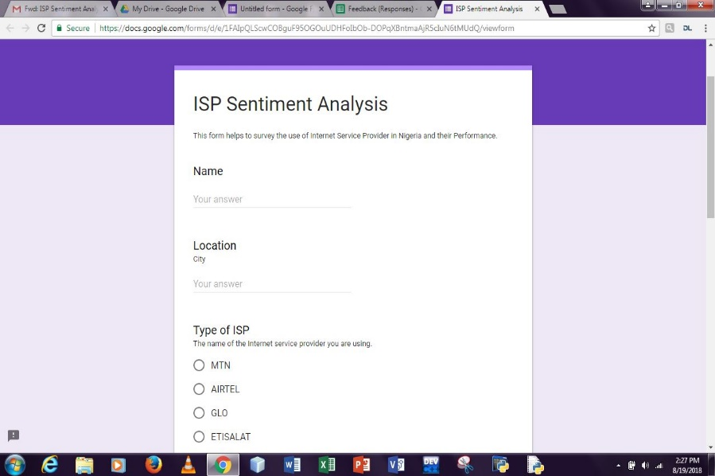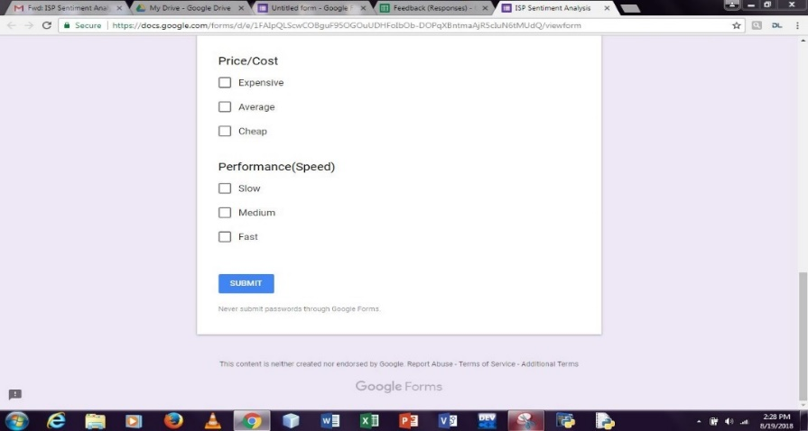

**Figure 1.4: Shows the Google form to be filled by the customers.**

* + - 1. **Social Platform/Media**

Social networking on social media websites involves the use of the internet to connect users with their friends, family and acquaintances. The most well-known social media platforms are Facebook, Twitter, WhatsApp, Instagram and LinkedIn. These websites allow you to share photos, videos and information, organize events, chat, and play online games.

Often, each of your “friends” (Facebook) or “followers” (Twitter) will be connected to each other. Just like in real life, the connections between people are not just one-on-one, but a network of connections. This online social network is useful for spreading information, pictures and videos and generally staying in touch with people you would not normally get to interact with all the time. For example, you can easily set up a Facebook page with details and pictures of an event you might be planning, such as a school fete. The page allows you to easily send out invitations to other users of the social media platform. Just like other technology, for example smartphones, social media is a very effective tool for connecting with people. However, there are a few privacy and security issues worth keeping in mind.

* + - 1. **Feedback**

A feedback is also called a response. It is the information about reactions to a product, a person’s performance of a task, etc. which is used as a basis for improvement.

* + - 1. **Database**

A database is a data structure that stores organized information. It allows collection of interrelated data. Most databases contain multiple tables, which may each include several different fields. Each of these tables would have different fields that are relevant to the information stored in the table.

* + - 1. **Natural Language Processing (NLP)**

Natural language processing (NLP) is the ability of a computer program to understand human language as it is spoken. NLP is a component of artificial intelligence (AI).Natural Language Processing (NLP) is “ability of machines to understand and interpret human language the way it is written or spoken”. The objective of NLP is to make computer/machines as intelligent as human beings in understanding language.

The ultimate goal of NLP is to the fill the gap how the humans communicate (natural language) and what the computer understands (machine language). NLP here helps to classify the opinion of the customers which can be positive, negative or neutral.

The algorithm to use is Naïve Bayes which can be extremely accurate. Naïve Bayes algorithm is a classification technique based on Bayes’ Theorem with an assumption of independence among predictors.

According to Sunil Ray (2017), Naïve Bayes model is easy to build and particularly useful for very large data sets. Along with simplicity, Naïve Bayes is known to outperform even highly sophisticated classification methods. Bayes theorem provides a way for calculating posterior probability P(c/x) from P(c), P(x) and P(x/c).

* P(c/x) is the posterior probability of class (c, target) given predictor (x, attributes).
* P(c) is the prior probability of class.
* P(x/c) is the likelihood which is the probability of predictor given class.
* P(x) is the prior probability of predictor.

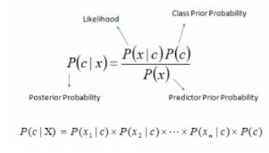

**Figure 1.5 shows the Algorithm for Naïve Bayes theorem**

* + - 1. **Recommendation**

Recommendation is the act of recommending or expresses commendation of the classified opinions of the customers to the ISPs involved.

**Use Case Diagram**

A use case diagram models the functionality of a system using actors and use cases.

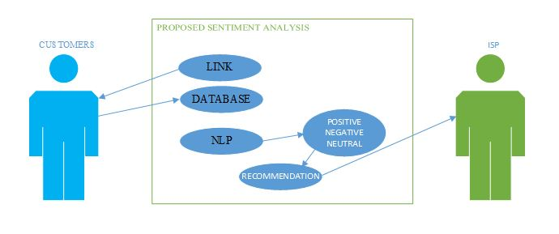

**Figure 1.6 shows the Use Case Diagram for this system**

The above diagram shows the functionality of the system using Use Case Diagram. A link is generated and sent to the ISP’s Customers through differs Social Media and then the customer submits their feedback into the database and then their feedbacks are classified into positive, negative or neutral using NLP and then recommendation is made.

1. **Experimental Evaluation**

**Procedure for Evaluation**

1. Getting and gathering of data
2. Downloading of the data gathered
3. Data processing
4. Analysis of data processed
5. Classification of analyzed data
   * + 1. **Getting and gathering of data**

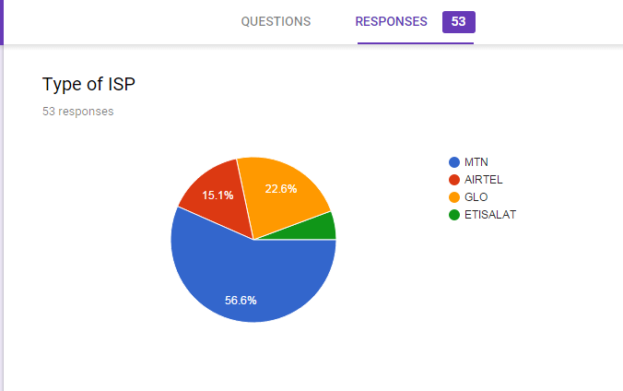The data used for this work is gotten from a questionnaire which was dispersed to users using Google form, data was gathered from 58 users. These data are then used to carry out the sentiment analysis. Below are the Google form evaluations of the data collected/responses.

**Figure 1.7: Responses for Type of ISPs**

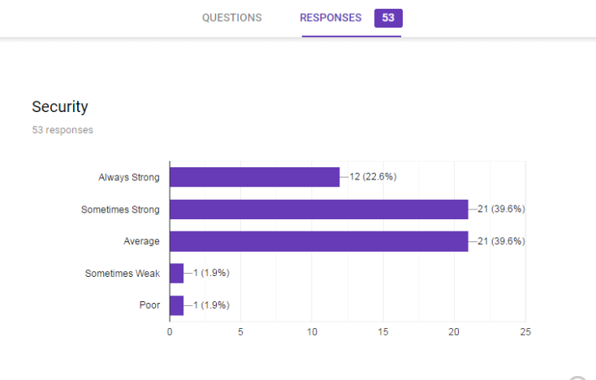**Figure 1.8: Responses for Security**

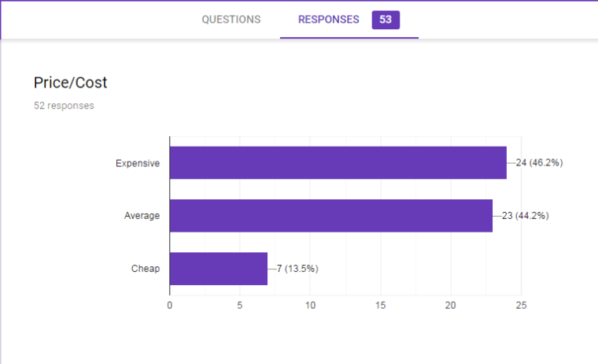**Figure 1.9: Responses for Cost**

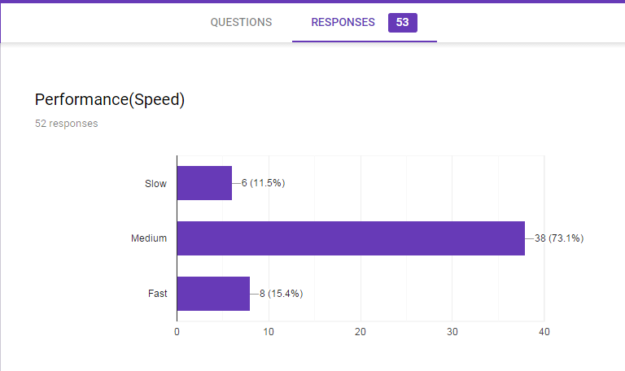

**Figure 1.10: Responses for Performance**

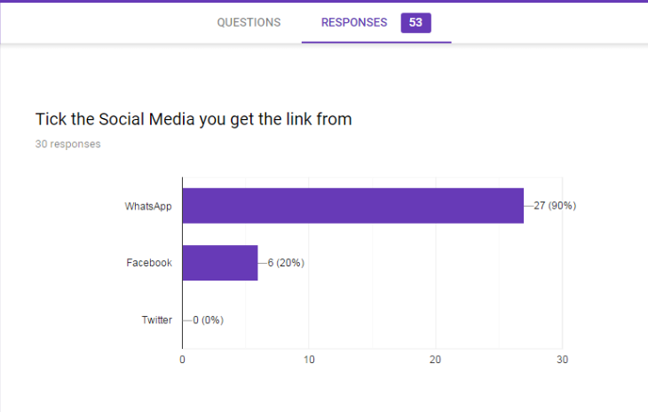

**Figure 1.11: Responses for Social Media**

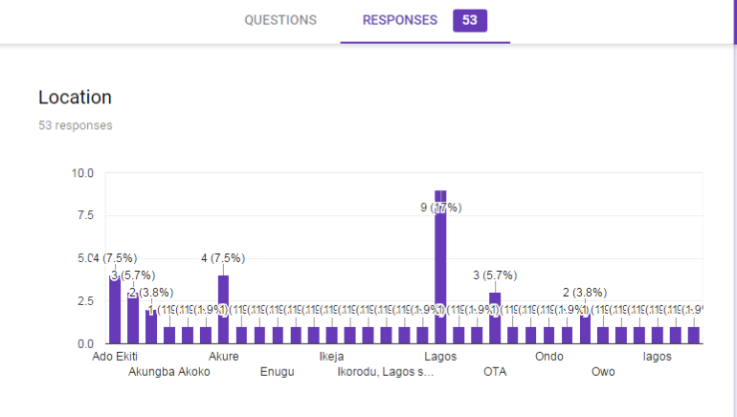

**Figure 1.12: Responses for Location**

* + - 1. **Downloading of data gathered**

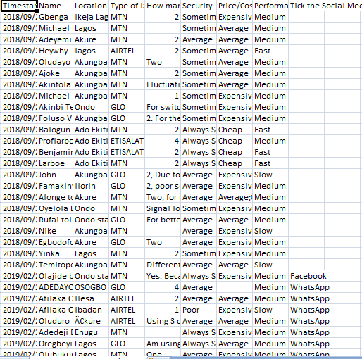The data collected was downloaded from goggle form excel sheet into a csv format, and saved into the working folder of this project.

**Figure 1.13: Downloaded Data**

* + - 1. **Data Pre-Processing**

The format of the collected data, which hardly provided us with the required information needed to carry out our sentiment analysis, so we carry out processing of the data using the python programming language in which we extracted the needed column and converted them into python json format. Below is the python code snippet used for the extraction. This code snippet is located in a file called extract.py.

The file is then extracted to a file name isp_data.json, shown below is the format of the extracted files.

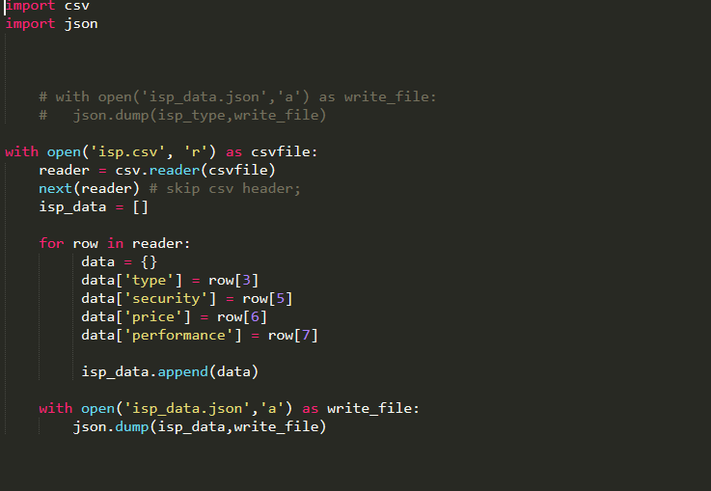

**Figure 1.14: Data Processing snippet**

* + - 1. **Analysis and Classification of Processed Data**

For the analysis of this work, the sentiment analysis carried out was done using, a natural language processing library called textblob.

Textblobis more of a natural language processing library, but it comes with a rule-based sentiment analysis library that we can use. TextBlob is built on the shoulders of NLTK and pattern. A big advantage of this is, it is easy to learn and offers a lot of features like sentiment analysis, pos-tagging, noun phrase extraction, etc. it has now become my go-to library for performing NLP tasks.

Enumerated below are the procedure used to carry out the analysis using Textblob library.

1. We imported the classifier used into our workspace as shown below.

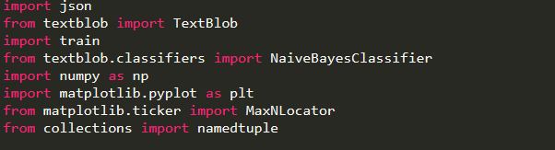

**Figure 1.15: Data Analysis snippet**

1. We then used the imported library to create an instance of our classifier, in our case we are using the NaiveBayesClassifier.
2. We then create our test and train data, to test and train our classifier in a file called train.py.
3. We then used our train classifier to analyze the Data based on the following criteria:
   1. Security of the service provider.
   2. Price of the service provider.
   3. Performance of the service provider.
4. The result of the analysis was stored in 9 separate python lists as shown below.

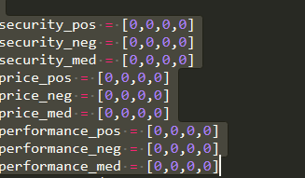

**Figure 1.16: Result of Analysis snippet**

In the list above the three consecutive list hold the analysis for the Positive, negative and neutral sentiments respectively.

1. We then used a data visualization library in python to present the result of our data as a bar chart.

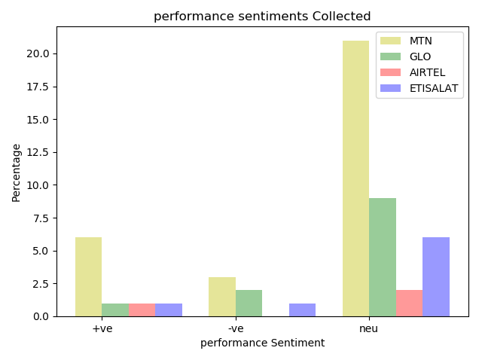**Evaluation Results**

**Figure 1.17: shows the Result for Performance Sentiment**

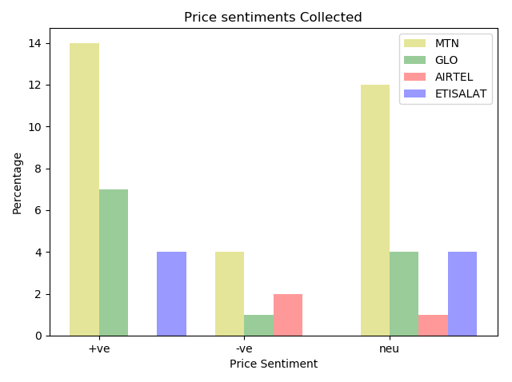

**Figure 1.18: shows the Result for Price Sentiment**

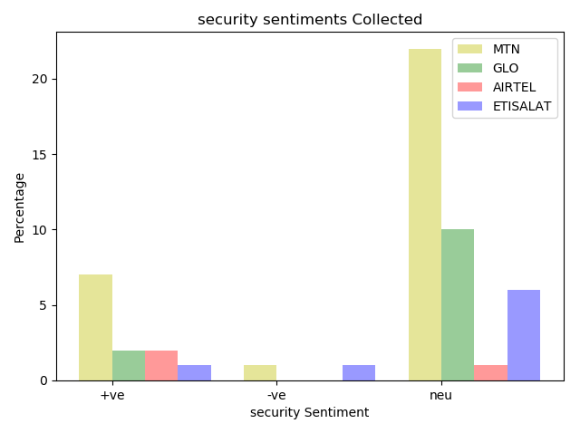

**Figure 1.19: shows the Result for Security Sentiment**

* + - 1. **Conclusion**

Customer service is generally a very sensitive issue with respect to an Internet Service Provider (ISP). There are a significant number of cases where customers switch ISPs frequently due to dissatisfaction and the general mediocrity in the ISP business. Consumers can get in touch with an ISP anytime - anywhere, due to which customer satisfaction becomes easily controllable for ISPs around the globe. Real-time and efficient customer service along with best-in-class technical support is two factors which control customer satisfaction. The foundation of a good ISP is flawless customer service and for it to be flawless, you need to ask the right questions about the executives of the customers.

It has been proven over the last decade that those ISPs who prioritize customer service definitely have an edge over the others in the market. It is advisable to send across this survey template to all your customers to know them better so that you can serve them better and retain them in this ever-growing and overcrowded ISP market. This questionnaire offers questions to obtain insights into ISP connection quality, installation process, the operating system used to contact customer service, customer service rating etc.

In a market as volatile as the ISP market, you must consider the importance of customer satisfaction and loyalty. With more than 50 ISPs catering to residential locations as well as businesses, customers have a lot of options to choose from and this makes it harder for each one of these ISPs to survive in this market. Customers choose those brands that value their time and money and put in efforts to make sure customer complaints are resolved in time.

An ISP service evaluation survey is the most effective medium for customers to vent out their dissatisfaction levels and also suggest areas for improvement. Building an intangible relationship with customers is what is needed for an ISP to succeed.

Customers can share their feelings about their experience with your company as an ISP, provide inputs about ease of installation and use and also rate the connection quality. For you to be able to provide best-in-class ISP services, you need to analyze responses received for all these aspects.

As discussed earlier, it is necessary for each and every ISP to provide something that the others in the market are not able to provide.

**REFERENCE**

1. ADOMI (2005). Internet Services in Nigerian Private University: A Case Study. In ISAAC ECHEZONAMANIYIRA (2011). Head, Technical Services Western Delta University Library.
2. AHMADI MOJTABA (2017). A Sentiment Analysis Application for Twitter Data. Tampere University of Applied Sciences Degree Programme in Information Technology.
3. ALIAKSEISEVERYN, ALESSANDRO MOSCHITTI*,*OLGA URYUPINA, BARBARA PLANK, KATJAFILIPPOVA (2017). Opinion Mining on YouTube. DISI - University of Trento, CLT - University of Copenhagen, Qatar Computing Research Institute, Google Inc.[severyn@disi.unitn.it](mailto:severyn@disi.unitn.it), [amoschitti@qf.org.qa](mailto:amoschitti@qf.org.qa),uryupina@gmail.com, bplank@cst.dk, [katjaf@google.com](mailto:katjaf@google.com).
4. ANU S. AND SAVLEEN K. (2016). Techniques for Sentiment Analysis Survey. IJCTA, 9(41), 2016, pp. 355-360, International Science Press.
5. ASUR S. AND HUBERMAN B.A. (2010). Predicting the Future with Social Media. <http://doi.org/10.1109/WI-IAT.2010.63>.
6. ASUR, S., AND HUBERMAN, B. A. (2010). Predicting the Future With Social Media. <http://doi.org/10.1109/WI-IAT.2010.63>. In ANU S.AND SAVLEEN K. (2016), Techniques for Sentiment Analysis Survey. International Science Press.
7. BIFET AND FRANK E. (2010). "Sentiment Knowledge Discovery in Twitter Streaming Data", In Proceedings of the 13thInternationalConference on Discovery Science, Berlin, Germany: Springer,2010, pp. 1-15.
8. BING LIU, (APRIL, 2012). Sentiment Analysis and Opinion Mining. Morgan & Claypool Publishers, May 2012.[liub@cs.uic.edu](mailto:liub@cs.uic.edu).
9. BLESSYSELVAM ANDABIRAM S. (2013). *A Survey on Opinion Mining Framework*. International Journal of Advanced Research in Computer and Communication Engineering. Vol. 2, Issue 9, 2013, pp.3544-3549.
10. BO PANG, LILLIAN LEE (2008), “*Opinion mining and Sentiment Analysis*”, Foundations and Trends in Information Retrieval, Vol. 2, Issue. 1, pp. 1-135.
11. CLIFFORD WOODY (2017). Research Methodology: Definition of Research and meaning of Research. Research Methodology.org. October 21, 2017.
12. DELENN AND ANNA, (2016) in Ahmadi Mojtaba (2017), A Sentiment Analysis Application for Twitter Data. Tampere University of Applied Sciences Degree Programme in Information Technology.
13. DMITRY DAVIDOV, ARI RAPPOPORT (2010)" Enhanced Sentiment Learning Using Twitter Hashtags and Smileys". Coling2010: Poster Volume pages 241{249, Beijing, August2010.
14. FALK J. D., (2011). Complaint Feedback Loop Operational Recommendations (<https://tools.ietf.org/html/rfc6449>). Retrieved 28 June 2012.
15. GERSON AND RYAN, (2012). A Primer on Internet Exchange Points for Policymakers and Non- Engineer (shttp://ssrn.com/abstract=2128103). Working Paper, August 11, 2012.
16. GO, BHAYANI R., HUANG L., (2009). “Twitter Sentiment Classification Using Distant Supervision". Stanford University, Technical Paper.
17. HAENLEINM. AND KAPLAN A. M. (2010). An empirical analysis of attitudinal and behavioral reactions toward the abandonment of unprofitable customer relationships, J. Relatsh. Mark., vol. 9, no. 4, pp. 200228, 2010.
18. HEREDIA B., KHOSHGOFTAAR T. M., PRUSA J., ANDCRAWFORD M., (2016). Cross-Domain Sentiment Analysis: An Empirical Investigation, 2016 IEEE 17th Int. Conference Inf. Reuse Integration, pp. 160165, 2016.
19. HOUSHMANDSHIRANI-MEHR (2015). Applications of Deep Learning to Sentiment Analysis of Movie Reviews. Department of Management Science & Engineering Stanford University hshirani@stanford.edu.
20. IRENEUSLUAMBANO AND JULITANAWE, (2004). “Internet Services in Nigerian Private University: A Case Study of Isaac Echezonam Aniyira (2011)”, Head, Technical Services Western Delta University Library.
21. JOHATCH, M. (2014). *Organization theory*. Translated by Dr. Danayifard H., Tehran. Mehban publications.
22. KOTHARI, C. R. (2004). *Research Methodology: Methods & Techniques*. *New Age International (P) Ltd*. <https://doi.org/10.1017/CBO9781107415324.004>
23. LUO F., LI C., AND CAO Z., (2016). Affective-feature-based sentiment analysis using SVM classifier. IEEE 20th Int. Conf. Computer. Support. Coop. Work Des., pp. 276281, 2016.
24. MONAVARIAN, A., ASGARI, N. AND ASHNA, M. (2007). “The Study of Relationship between Organizational Structure” in Ahmady, G.A., Maryam M. and Aghadas N. (2016). “Organizational Structure – Science Direct. 3rd International Conference on New Challenges in Management and Organization: Organization and Leadership, 2 May 2016, Dubai, UAE.
25. MU’AZUABDULLAHI SAULAWA1, JUNAIDU BELLO MARSHALL, PROF. DR. IDA. MADIEHABT. ABDUL GHANI AZMI (2015). The Significance of Internet Service Providers in Nigeria: An Overview of Legal Perspective. Global Journal of Politics and Law Research.
26. PAK A., AND PAROUBEK P., (2010). Twitter as a Corpus for Sentiment Analysis and Opinion Mining". In Proceedings of the Seventh Conference on International Language Resources and Evaluation,2010, pp.1320-1326
27. PO-WEI LIANG AND BI-RU DAI, (2013). “Opinion Mining on Social Media Data", IEEE 14th International Conference on Mobile Data Management, Milan, Italy, June 3 - 6, 2013, pp 91-96, ISBN: 978-1-494673-60685, http://doi.ieeecomputersociety.org/10.1109/MDM.2013.
28. PRANALIBORELE AND DILIPKUMAR A. BORIKAR (FEB-2016). A Survey on Evaluating Sentiments by Using Artificial Neural Network. International Research Journal of Engineering and Technology (IRJET). Volume: 03 Issue: 02. Feb-2016 [www.irjet.net](http://www.irjet.net).
29. REZAYIAN, A. (2005). *The basics of organization and management*. Tehran. SAMT publications.
30. ROEBUCK (2012). in Frederick F. P., Alvin R. M., and Proceso L. F. Computer Science and Information Technology (2015).
31. SOMMERVILLE (2011). System Modelling Sommerville. “Software Engineering”, 9th Edition, 2011.
32. STEFAN SIERSDORFER, SERGIU CHELARU, WOLFGANG NEJDL, AND JOSE SAN PEDRO. (2010). How useful are your comments? Analyzing and predicting YouTube comments and comment ratings.
33. SUNIL RAY (2017). 6 Easy Steps To Learn Naïve Bayes Algorithm (with codes in Python). Computer Vision Using Deep Learning. September 11, 2017.
34. The Punch Newspaper (2018). [www.punchng.com/poor-internet-services](http://www.punchng.com/poor-internet-services), 22 may, 2018.
35. THIENHAINGUYEN, KIYOAKISHIRAI, JULIENVELCIN (2015). Sentiment Analysis on Social Media for Stock Movement Prediction. Expert Systems With Applications 42 (2015) 9603–9611.
36. TURNEYP.D., (2002). “Thumbs up or thumbs down? Semantic orientation applied to unsupervised classification of reviews,” in Proceedings of the 40th annual meeting on association for computational linguistics, pp. 417–424, Association for Computational Linguistics.
37. VISHAL A. KHARDE&SONAWANE S. S. (APRIL-2016). Sentiment Analysis of Twitter Data: A Survey of Techniques. Department of Computer Engr., Pune Institute of Computer Technology, Pune University of Pune (India). International Journal of Computer Applications (0975 – 8887) Volume 139 – No.11, April 2016.
38. VANGUARD NEWSPAPER (2017). NCC laments poor quality of data Services. September 20, 2017.
39. YADAV, S. K. 2015. Sentiment Analysis and Classification: A Survey. In ANU, S. & SAVLEEN, K., (2016). Techniques for Sentiment Analysis Survey. International Science Press.
40. YEOLE A. V., CHAVAN P. V., AND M. C. NIKOSE, (2015). Opinion mining for emotions determination, ICIIECS 2015 - 2015 IEEE Int. Conf. Innov. Information, Embed. Communication. System., 2015.